PC Builder Web Application

Kevin Song, SiYuan He, Xu Zhang, HaiMiao Yu, Chhanna Gaha, SiChao Liu

*CS691*

*Seidenberg School of Computer Science and Information Systems*

*Pace University, New York, NY, USA*

***Abstract* —With the rapid development of technology, computers have already become an essential part of our life, especially for students as well as people who are engaged in the information technology field. Since nowadays people rely much on computers, a suitable computer can significantly improve the efficiency of their daily jobs. Although it is easy for us to purchase any computer or parts online, choosing a hardware configuration of a computer can still make us very indecisive. A computer without an appropriate configuration will potentially cost more to upgrade later. Therefore, the purpose of our project is to help people purchase the hardware of a computer which can highly meet their needs. Also, our application will sync our users with the most recent technology not only because of the dynamic change of user needs but also the rapid iteration of technology.**

***Keywords***—**PC hardware**, **web application, PC builder**

1. Introduction

This web application provides specialized hardware guidance for different groups of customers such as students, engineers and so on. Today people benefit from web services a lot with its advantage on reducing cost and saving time. We are going to apply the Responsive Web design to make the user feel comfortable with the browsing experience when they visit our website.

In our application, we will use React and MongoDb as a database to support the frontend application. Here are some basic processes for the new user when they visit our website the first time. First, when they visit our website, they will be directed to the main sale page with sign in function. Then they can have a quick registration. Our website will ask users to enter their name and email address. As long as they finish this simple registration. The website will add the user to database and remember his selection. Once user registered. The users can login onto their account by their email address and password next time.

Moreover, after the user logs in onto their account, they can get some hardware products when they enter some keywords in the search bar. Before they use the search bar, we have filter system which classified our product in many category include: student, film, gamer, office etc.… if the user is a student who is majoring in computer science, we will provide them with hardware suitable for database programming, game design, and many other computer science related tasks.

Last but not least, we have the forum for users to share their experience of purchasing the hardware and their specific specs to fulfill their requirements. They can comment on other users’ purchase plans as well. Our website will also have a section which shares technical articles to educate users with knowledge regarding PC hardware.

1. Literature Survey

As we all know, there are plenty of manufactures providing customized hardware products to meet the needs of the customers. However even with so many modernized online shopping platforms, it is still not straightforward for users to find a hardware product with satisfaction.

Based on our survey, there are some common pain points people may have for their computers. Some people complained of the issue of the computer not being responsive once they use it to watch their favorite TV series. Other people are glooming about hardware overheating and the concern for safety. And another quite common problem people have is the tradeoff between limited budget and performance.

When we did customer research, we met with two users who can represent a significant number of users. Nancy, a Computer Science student, found that there are so many laptop brands with similar hardware. As a result, she had a hard time making a purchase decision.

Han, an Engineer who is an experienced IT professional, still struggles to find right PC hardware which can match his field of work.

With our survey and research, we can see that finding the right hardware configuration with a limited budget is a general challenge faced by everyone. This is also our solution’s market fit. Our solution tries to provide a one-stop experience to facilitate and guide customers to find hardware to meet their technical and financial requirement in a timely fashion.

1. Project Requirements

Software Requirements:-​

Mozilla Firefox 4.0 or above, Microsoft Edge, Google Chrome.

Hardware Requirements:-

● We need the version of the processor after Intel Core 2 Duo.

● The operating System should be capable of running the browsers.

Functional Requirements:-

● We should enable user to login and register easily.

● We should differentiate user and admin user.

● We should redirect logged-in users to the homepage.

● We should keep the user logged until user logout manually.

● Users should be able to add desired item to cart

* Cart should remember item

Refresh screen will not discard item

● Users can upload, edit and delete their user profile.

● Users can purchase product and add shipping.

● The administrators can manage user information and check any order placed by user.

Technical Requirements:

* This is a web application which should support users browse from PC end and mobile end.
* This web app will be implement using react, node.js, redux, postman.
* Other technologies used would be HTML, CSS, and Mongo dB Compass.

Usability Requirements:

● The web application will be functional in all the major web browsers.

● The web application will have a simple user interface

1. System Diagrams

User-Case Diagram

ADMIN-



USER-



1. Database

Table Name: **UserModel**

Description: To store the details of user and admin

|  |  |  |
| --- | --- | --- |
| **Fields** | **Data Types** | **required** |
| id |  | true |
| User_name | String | true |
| Email | String | true |
| Password | String | true |
| IsAdmin | Boolean | Default:false |

Table Name: **ProductModel**

Description: To store the details of user and admin

|  |  |  |
| --- | --- | --- |
| **Fields** | **Data Types** | **required** |
| price | Number | true |
| name | String | unique |
| image | String | true |
| brand | string | true |
| category | String | true |
| description | String | true |
| countInStock | Number | true |
| numReviews | Number | true |

Table Name: **Product_Config**

Description: To store customization info

|  |  |  |
| --- | --- | --- |
| **Fields** | **Data Types** |  |
| Harddrive | String |  |
| cpu | String |  |
| memory | String |  |
| motherboard | String |  |

Table Name: **OrderModel**

Description: order Items

|  |  |  |
| --- | --- | --- |
| **Fields** | **Data Types** | **required** |
| name | String | true |
| qty | Number | true |
| image | String | true |
| price | Number | true |
| product | It is getting type from database Object Id | true |

Description: To store shipping Address

|  |  |  |
| --- | --- | --- |
| **Fields** | **Data Types** | **required** |
| fullName | String | true |
| address | String | true |
| city | String | true |
| postalCode | String | true |
| country | String | true |

Description: To store item status

|  |  |  |
| --- | --- | --- |
| **Fields** | **Data Types** | **required** |
| itemsPrice | Number | true |
| totalPrice | Number | true |
| user | It is getting type from Object Id | true |
| isPaid | Boolean | false |
| PaidAt | Date |  |

1. Data Modeling





1. ADVANTAGES
2. React runs in browser, the web app is going to react fast.
3. React is a component driven framework, many components can be reuse in the future implementation.
4. Redux is added to manage stat, many errors can be detected, also post man can easily test API for backend.
5. Future Scope

For next stage, we have plan for several new features and functions.

1. Give admin ability to edit user, product
2. A user profile page
3. User will have option to customize their pc.
4. A forum will be created as a community for our users.
5. Rating system.
6. Potential ability for user to chat with admin.
7. Optimization of the web page interface.

We will hold virtual scrum meetings to scrum back

1. Product results

Here are the screenshots of the website implemented so far.

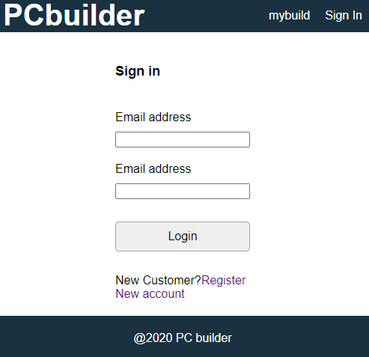

Figure 1. Login page

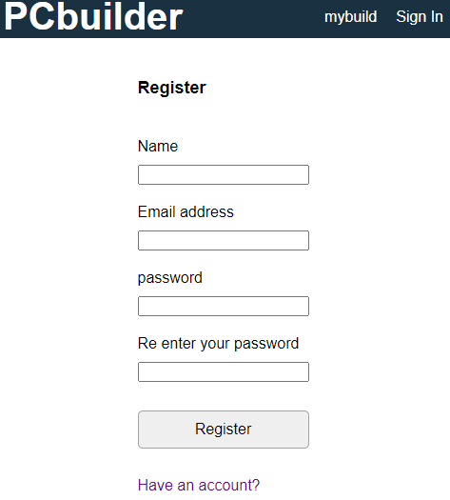

Figure 2. Register page

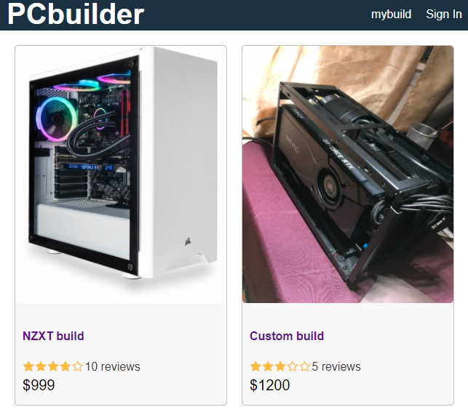

Figure3: Main page

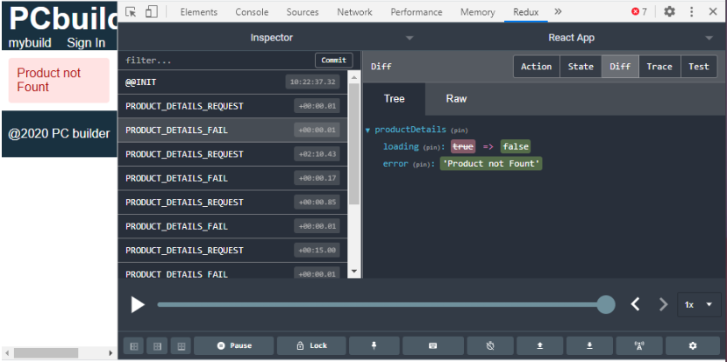

Figure4: Redux stat

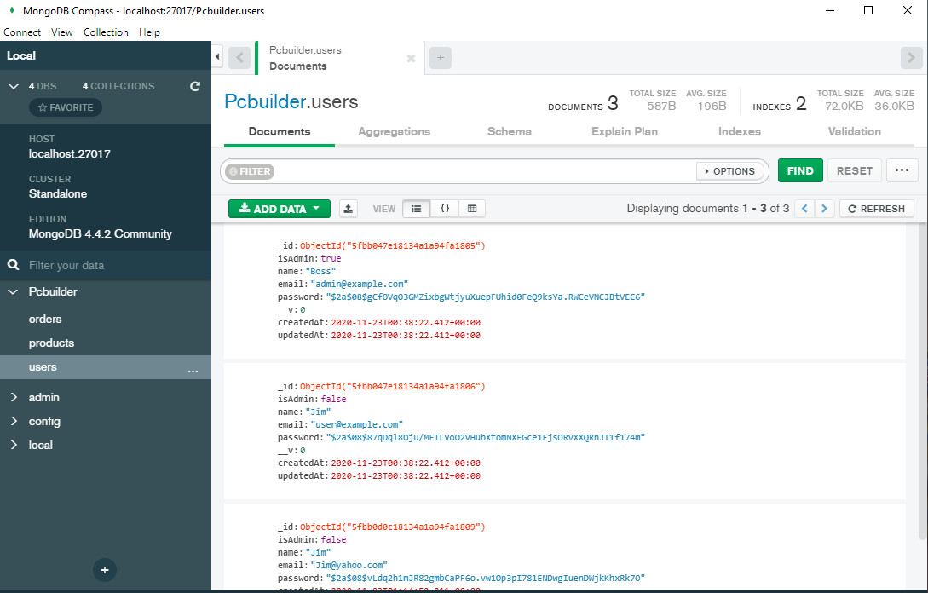

Figure5: MongoDb with added User Jim

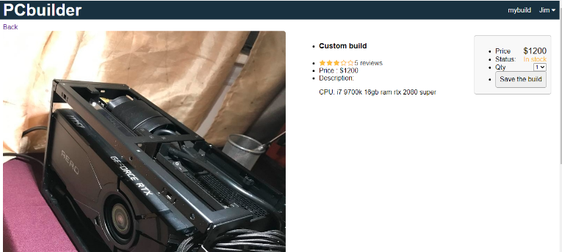

Figure6: MongoDb with added User Jim

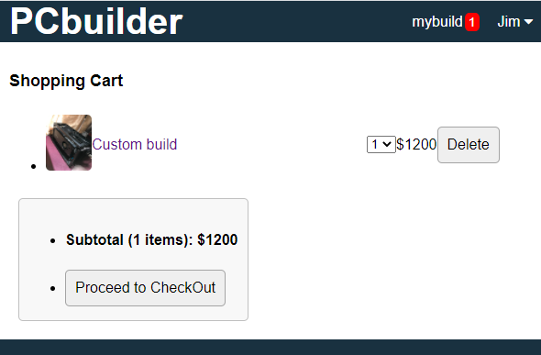

Figure7: Shopping cart with 1 saved item by jim

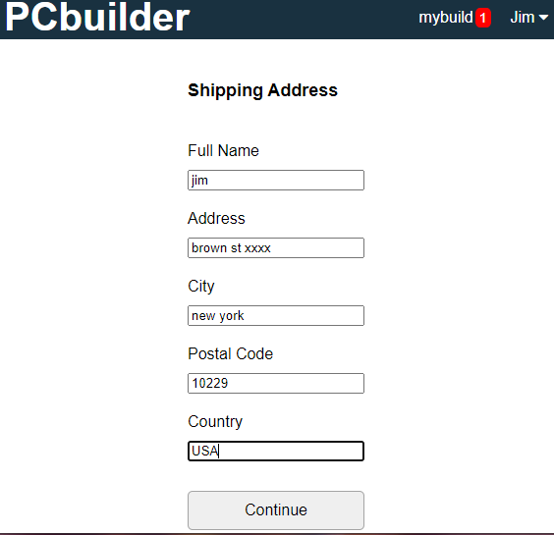

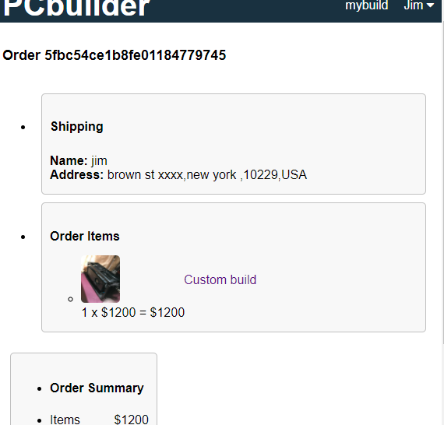

Figure9: Final order with token generated ID

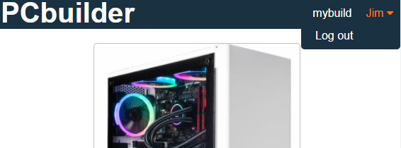

Figure10: Normal user logout

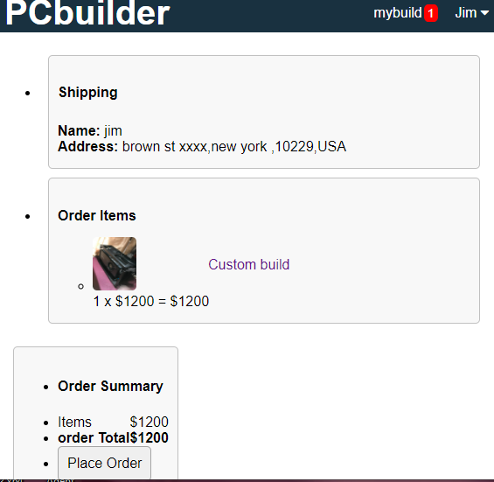

Figure8: redirect after click check out

Figure11: Order summary page before official check out

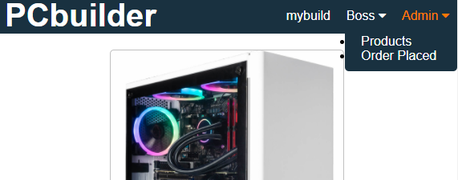

Figure12: Admin user login

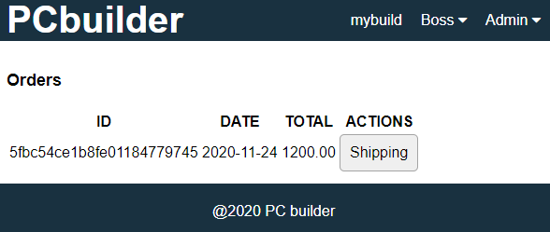

Figure13: Click on order placed, admin see order.

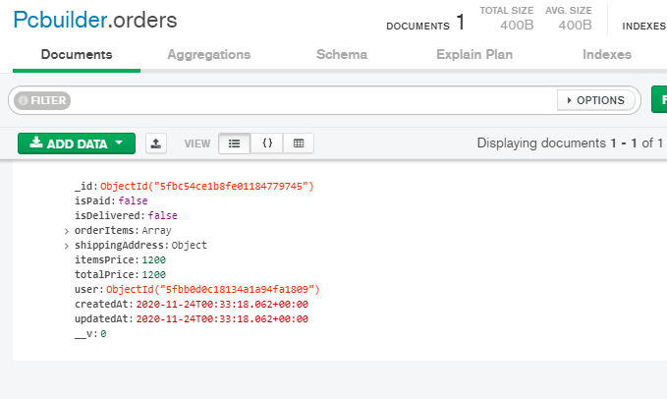

Figure14: Order successfully saved in database

1. Conclusions

The importance of computers remains and integral part of modern society and it is imperative that users of various backgrounds have a simple and intuitive platform in which to not only buy a computer, but to have it customized to his or her needs and budget. In this paper, we introduced the PC Builder web application developed in React and implementing Google Firebase, allowing for a modern and smooth user experience.

The aim of this work is to create a simple yet powerful website that conglomerates the latest computer parts on the market into one place. We want to eliminate the intimidating aspect of buying a customized PC by incorporating an easy to use interface where casual buyers can create a computer that balances both their personal needs and budget. Enthusiasts can find more detailed options allowing for advanced customization and part searches. Finally, with the addition of the rating system, forum section, and tech news pages, we aim to make the web app an interactive and social platform as well.

Reference

1. O. Molly, “Common PC Hardware Problems” *Remosoftware*, 15-Jun-2020. [Online]. Available:

<https://www.remosoftware.com/info/common-pc-hard-ware-problems>. [Accessed: 04-Oct-2020].

1. H. John, “Fixes for Six Common Laptop Problems” *Remosoftware*, 08-Sept-2020. [Online]. Available:

https://www.remosoftware.com/info/fixes-six-common-laptop-problems. [Accessed: 04-Oct-2020].

1. “Computer hardware,” *Wikipedia*. [Online]. Available:

https://en.wikipedia.org/wiki/Computer_hardware.[Accessed: 05-Oct-2020].

1. “What is Computer Hardware?” *Crucial*. [Online]. Available: https://www.crucial.com/articles/pc-builders/what-is-computer-hardware[.](https://firebase.google.com/docs/auth) [Accessed: 05-Oct-2020].
2. F. Tim, “Everything You Need to Know About Computer Hardware” *Lifewire*, 11-Sept-2020. [Online]. Available:

https://www.lifewire.com/computer-hardware-2625895. [Accessed: 05-Oct-2020].

1. “Computer Hardware Types” *Wikiversity*. [Online]. Available:

https://en.wikiversity.org/wiki/Computer_Hardware_Types. [Accessed: 06-Oct-2020].